SQL REVOKE

📌 What is REVOKE?
# Source: AI Source: Provided by: [Data Path: Persons Table -> ID Column: 1, Name_En Column: Motasem Essam] -> From: [ChatGPT] on [6/11/2026]
The REVOKE statement in SQL is used to remove previously granted privileges from a user or role.

📘 Syntax
# Source: AI Source: Provided by: [Data Path: Persons Table -> ID Column: 1, Name_En Column: Motasem Essam] -> From: [ChatGPT] on [6/11/2026]
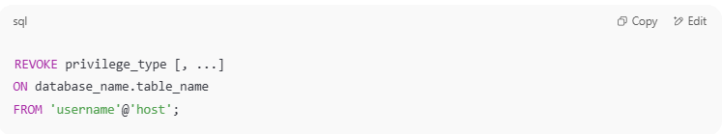
REVOKE privilege_type [, ...]
ON database_name.table_name
FROM 'username'@'host';

✅ Example Scenario

Step 1: Create a database and table
# Source: AI Source: Provided by: [Data Path: Persons Table -> ID Column: 1, Name_En Column: Motasem Essam] -> From: [ChatGPT] on [6/11/2026]
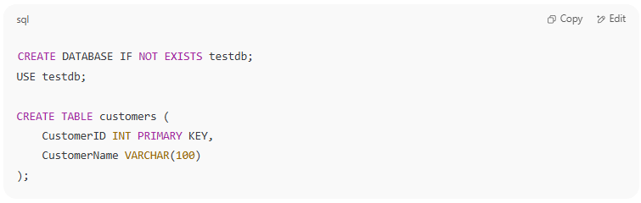
CREATE DATABASE IF NOT EXISTS testdb;
USE testdb;

CREATE TABLE customers (
CustomerID INT PRIMARY KEY,
CustomerName VARCHAR(100)
);

Step 2: Create a user and grant privileges
# Source: AI Source: Provided by: [Data Path: Persons Table -> ID Column: 1, Name_En Column: Motasem Essam] -> From: [ChatGPT] on [6/11/2026]
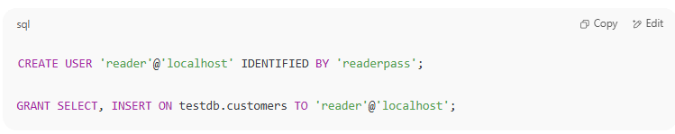
CREATE USER 'reader'@'localhost' IDENTIFIED BY 'readerpass';

GRANT SELECT, INSERT ON testdb.customers TO 'reader'@'localhost';

Step 3: Revoke privileges
# Source: AI Source: Provided by: [Data Path: Persons Table -> ID Column: 1, Name_En Column: Motasem Essam] -> From: [ChatGPT] on [6/11/2026]
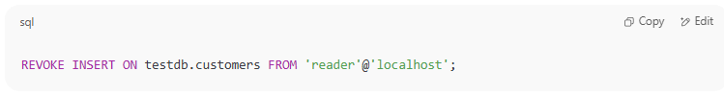
REVOKE INSERT ON testdb.customers FROM 'reader'@'localhost';

This command removes only the INSERT privilege, but the SELECT privilege will remain.

Step 4: Check privileges
# Source: AI Source: Provided by: [Data Path: Persons Table -> ID Column: 1, Name_En Column: Motasem Essam] -> From: [ChatGPT] on [6/11/2026]
To confirm what privileges remain:
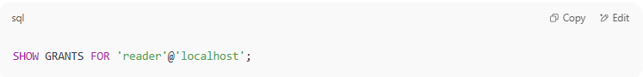
SHOW GRANTS FOR 'reader'@'localhost';

💡 Notes
# Source: AI Source: Provided by: [Data Path: Persons Table -> ID Column: 1, Name_En Column: Motasem Essam] -> From: [ChatGPT] on [6/11/2026]
- You can revoke all privileges by specifying each one individually or using REVOKE ALL PRIVILEGES.
- REVOKE only works if the privileges were previously granted.
- After revoking privileges, users might need to log out and log in again to refresh their session permissions.

Example

prepared commands
# Source: ScreenShot Source: Provided by: [Persons Table -> ID Column: 1, Name_En Column: Motasem Essam] -> Tool: [Automation Table -> ID Column: 16, Name_En Column: Screen Capture] -> From [Operating System: Wampserver64 -> phpmyadmin] on [6/11/2026]
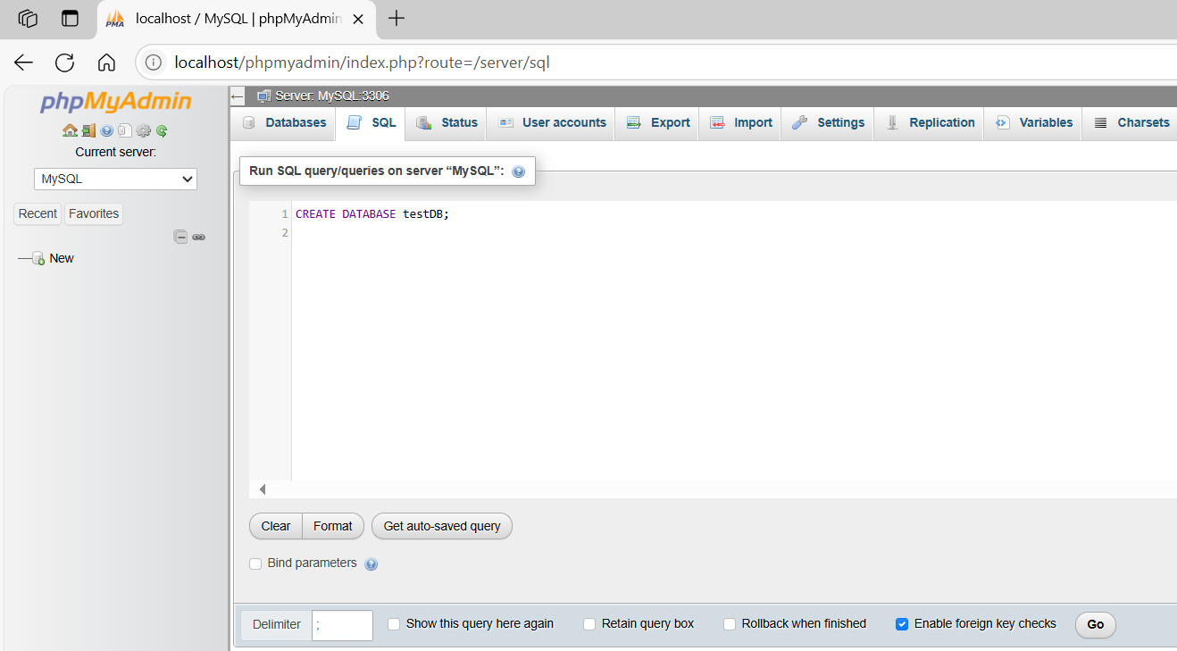
CREATE DATABASE testDB;
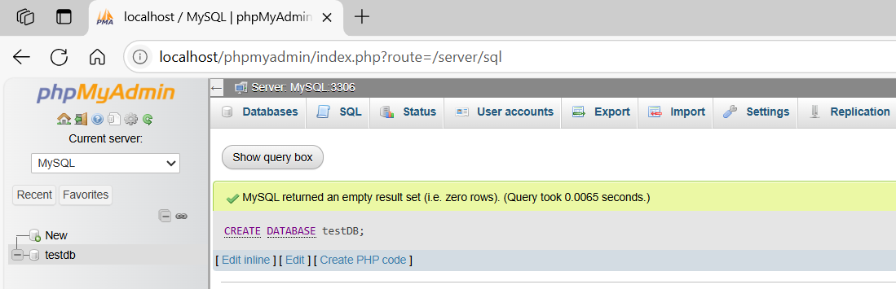
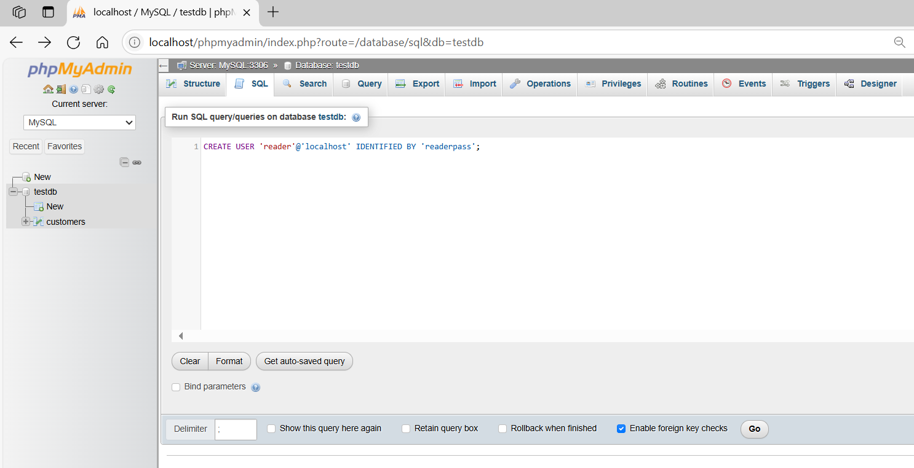
CREATE USER 'reader'@'localhost' IDENTIFIED BY 'readerpass';
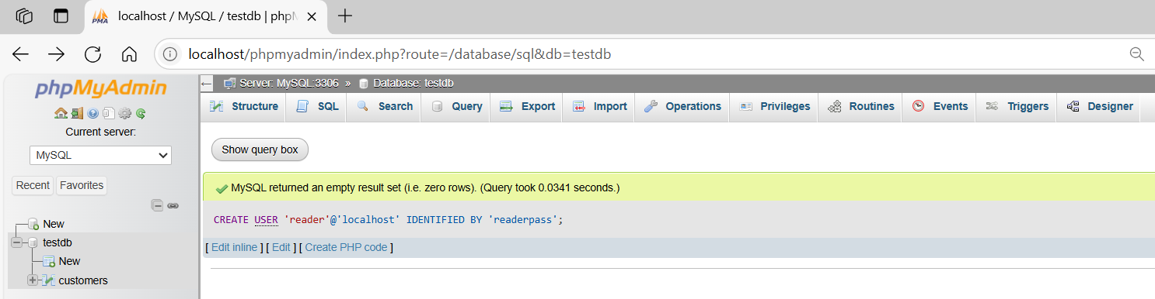
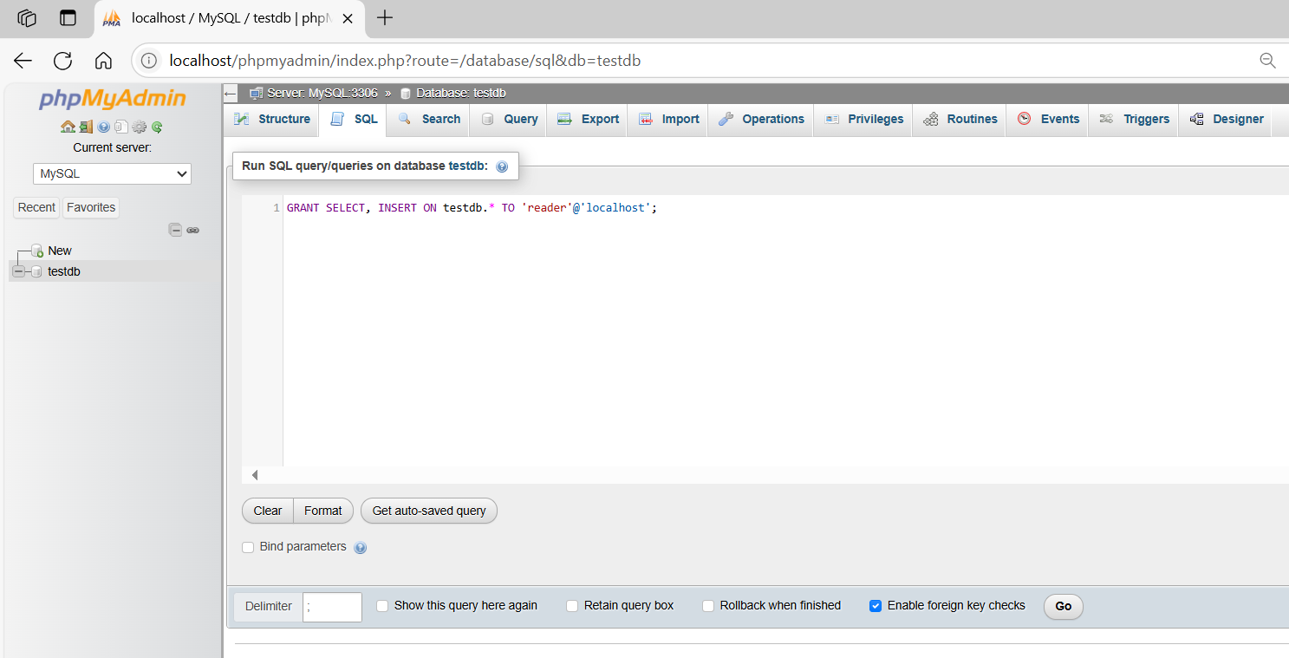
GRANT SELECT, INSERT ON testdb.* TO 'reader'@'localhost';
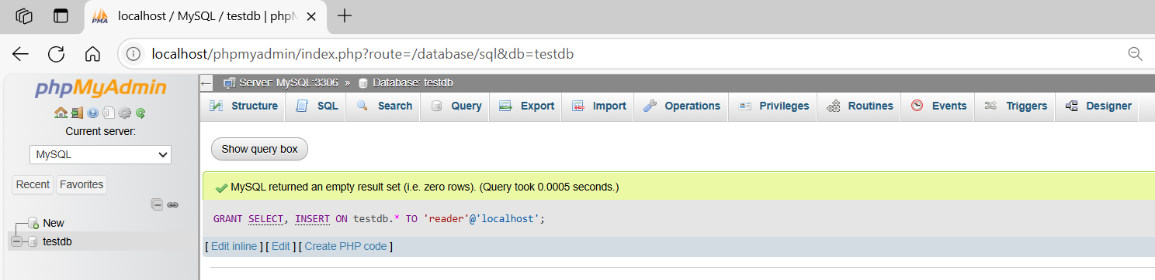
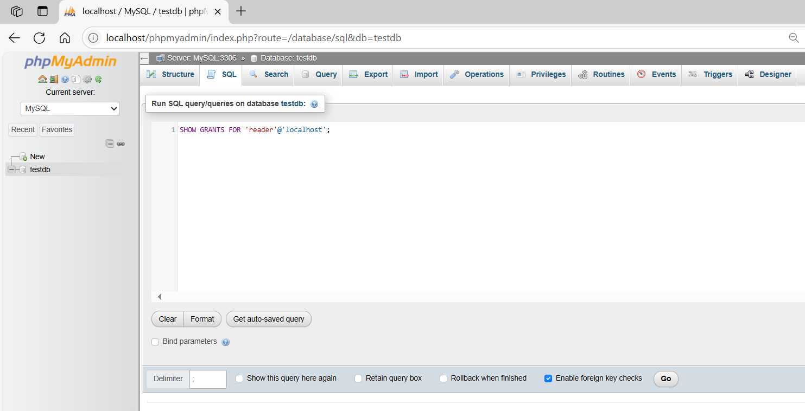
SHOW GRANTS FOR 'reader'@'localhost';
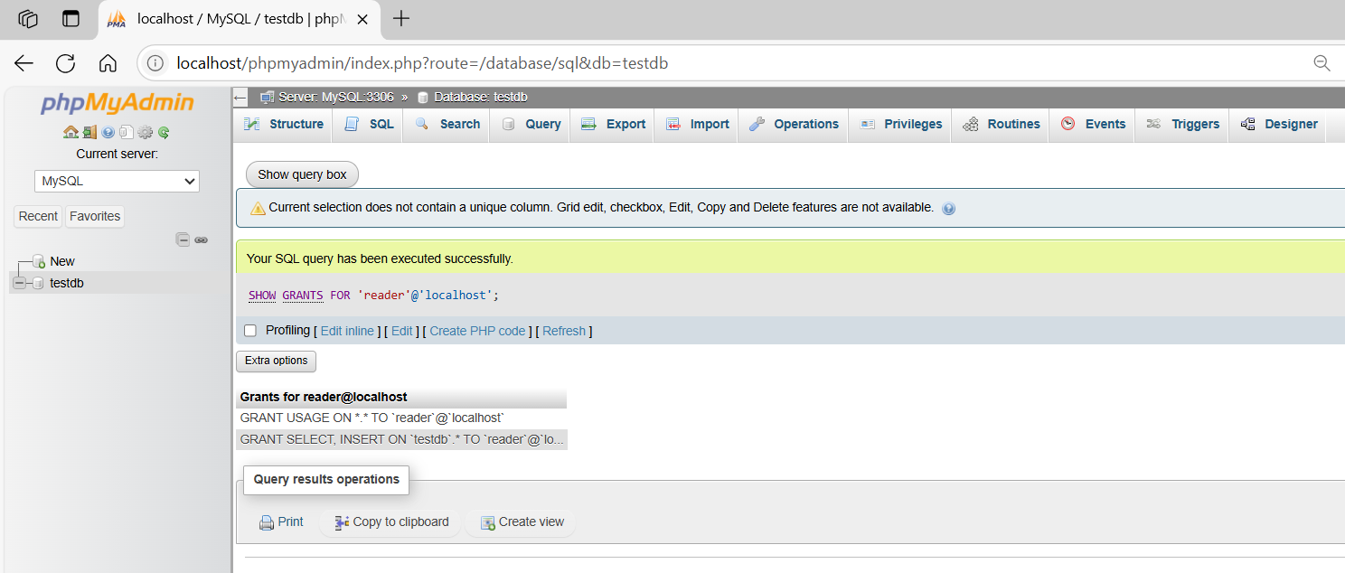

basic command
# Source: ScreenShot Source: Provided by: [Persons Table -> ID Column: 1, Name_En Column: Motasem Essam] -> Tool: [Automation Table -> ID Column: 16, Name_En Column: Screen Capture] -> From [Operating System: Wampserver64 -> phpmyadmin] on [6/11/2026]
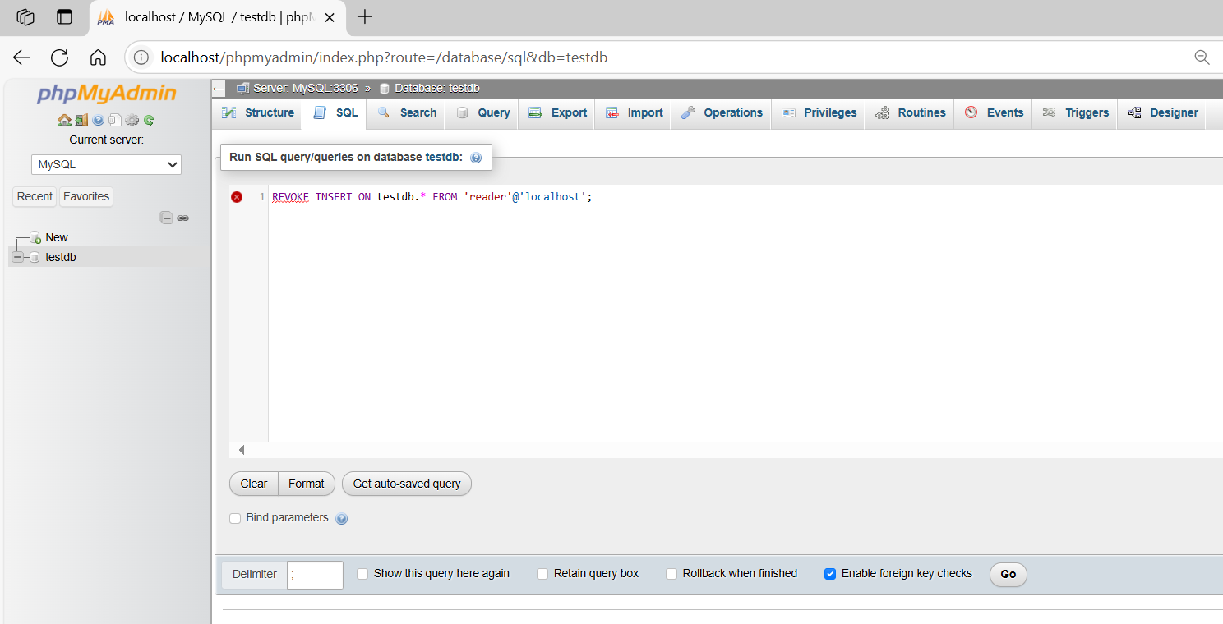
REVOKE INSERT ON testdb.* FROM 'reader'@'localhost';
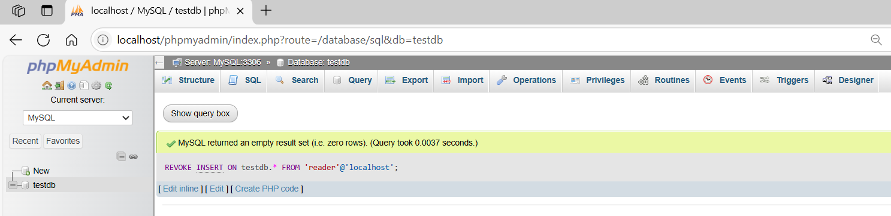

SHOW GRANTS FOR 'reader'@'localhost';
